**EDS-ASSIGNMENT NO. 1**

**NAME : Sukanya Hanmant Mane**

**PRN NO. : 202201090017**

**ROLL NO : 335**

**Batch : C-2**

**Code for student information**

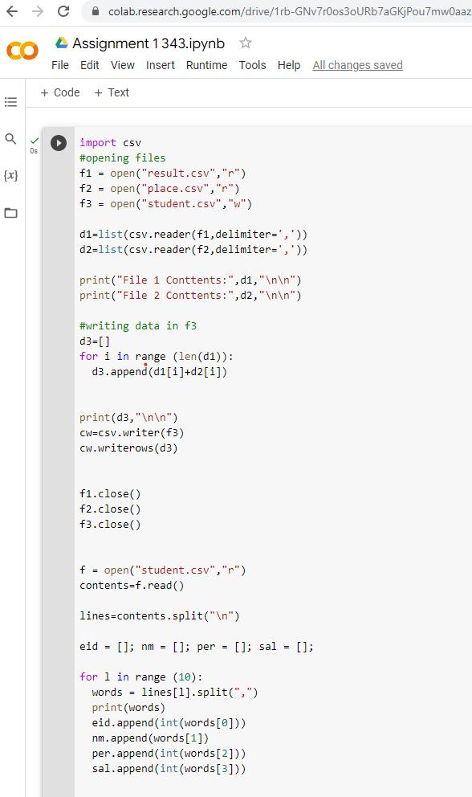

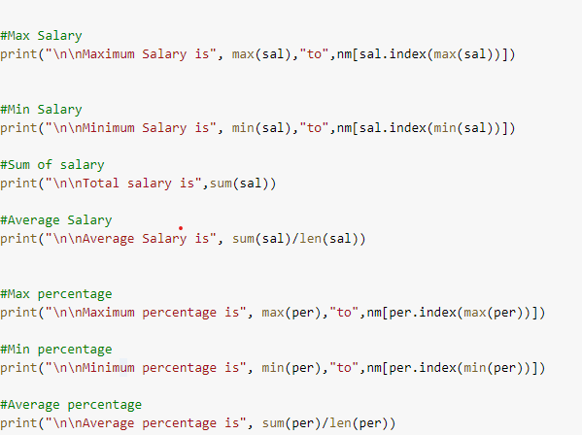

Program Output

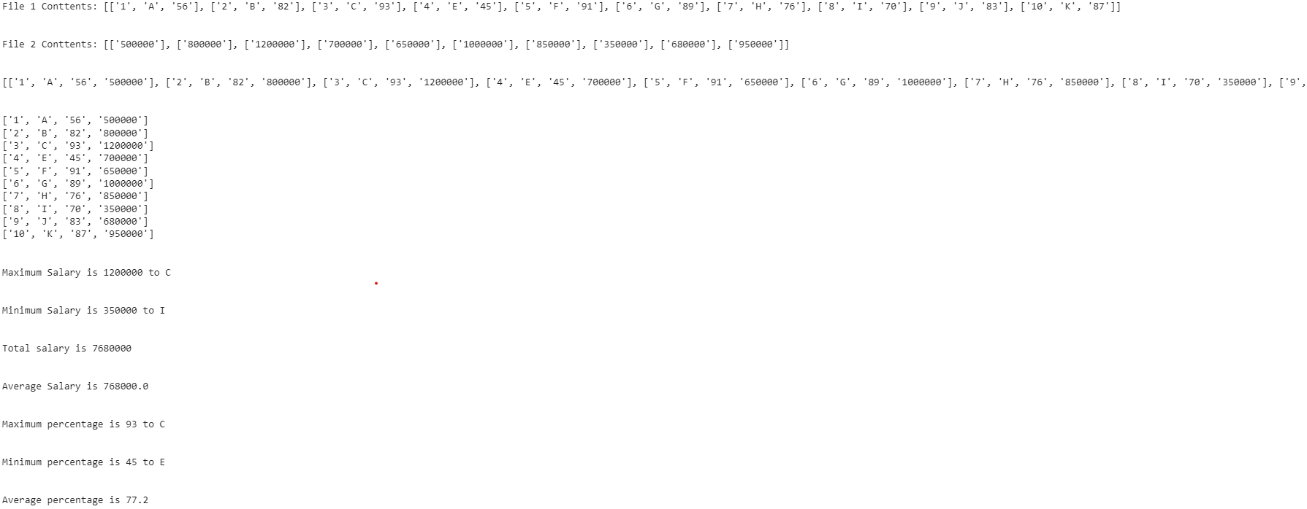

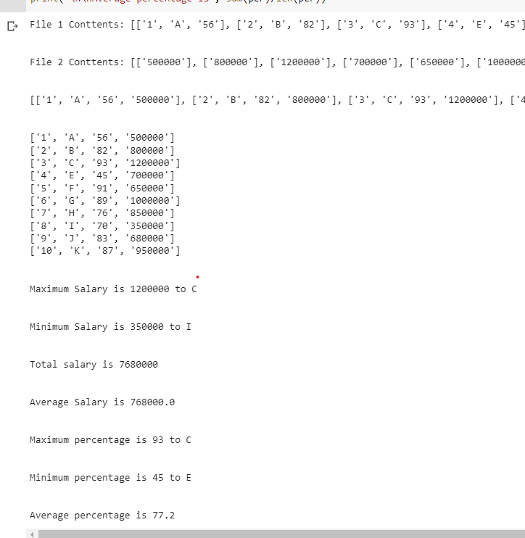

**Pdf link of program :**

<https://drive.google.com/file/d/1Q821oRTN_zJB34_HkA9YRKTcIFDekLFR/view?usp=share_link>

**Links for Files :**

1. **<https://drive.google.com/file/d/1uJdu1HRgRXwf0uFz-BlboEdA9UteJuXY/view?usp=share_link>**
2. **<https://drive.google.com/file/d/14bE1gAo_7mDCCTYBP2nsHXW-SIY0u57s/view?usp=share_link>**

**Link for colab**

**<https://colab.research.google.com/drive/1rb-GNv7r0os3oURb7aGKjPou7mw0aazl?usp=sharing>**